# Lab 7 Design and Layout of an Embedded System

Allen Pan & Paris Kaman

1. Overview

**1.1. Objectives**

This project’s purpose is to design our pcb that we will be using in the final lab.

**1.2. Roles and Responsibilities**

As a group, we will design project we will later implement in the final lab. We will design the circuit schematic that we will be using and design the pcb using that schematic. The clients for the project are the graders; the TAs and Professor McDermott.

**1.3. Interactions with Existing Systems**

We are not connecting to any other existing systems.

2. Function Description

**2.1. Functionality**

We are going to implement a home security system. When a person approaches the door, the motion detector senses it and activates the monitor, which allows the house owner see the live video inside the house. A microphone is used for communication across the door (imagine the monitor is somewhere far from the door). There will a button for the bell, and a keypad for passcode input to unlock the door. Door lock and unlock will be demonstrated using a servo. If the person cannot input the correct code in three attempts, the system will sound an alarm and send an sms message to the owner informing the intrusion. The user can change the passcode of the system at any time. Ideally there is supposed to be a speaker and a microphone both the outside and inside, but for demonstration purpose we will only use one set.

**2.2. Performance**

The system will have to have low latency for the I/O devices to feel responsive to the user.

The audio of the system will ideally have an SNR close to that of our previous audio lab (49.3 dB)

**2.3. Usability**

The system will likely have a 12-button keypad, a button, a motion detector, a camera, a microphone as input, and have a speaker and 2 LCDs as output. The 12-button keypad and button are the only input the user will interact with directly while the other three will provide input on their own if certain conditions are met.

3. Deliverables

**3.1. Report**

this is the report.

**3.2. Outcomes**

B) Hardware Design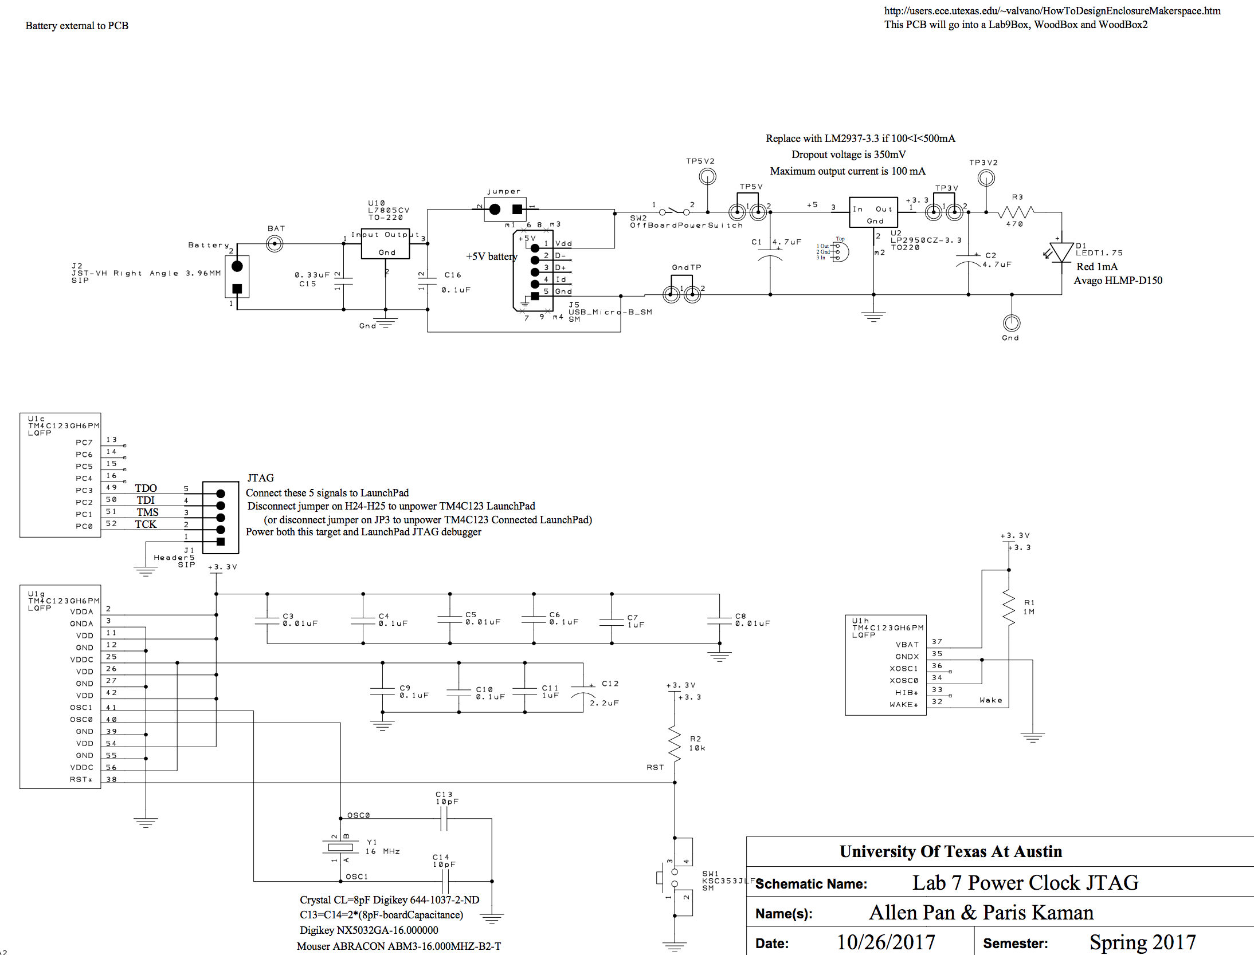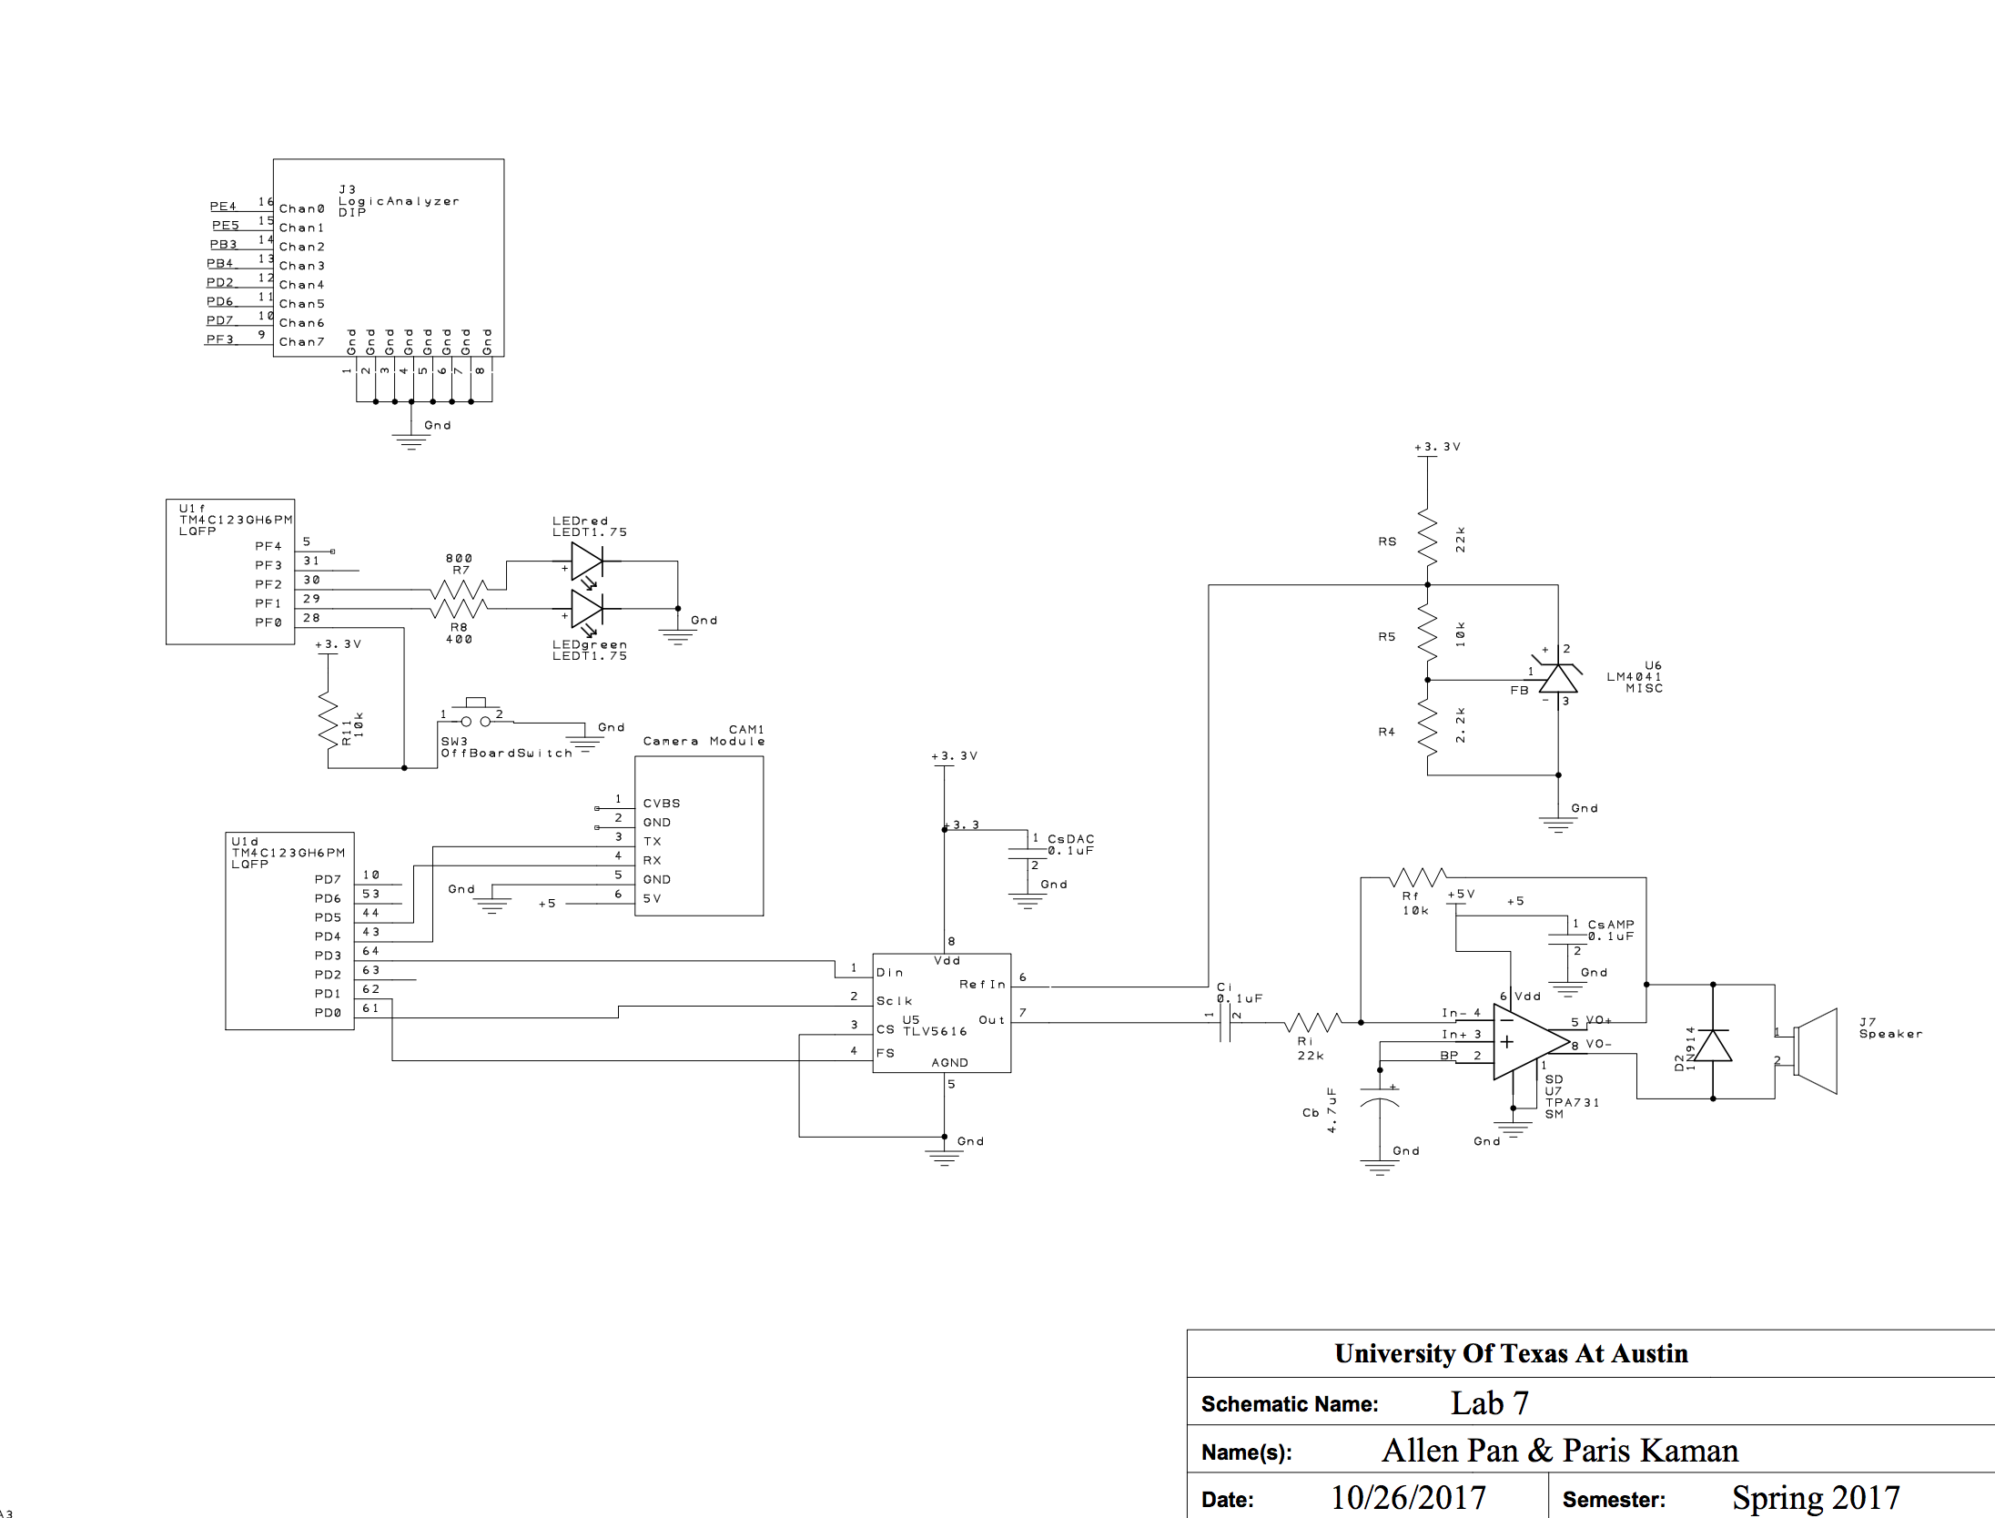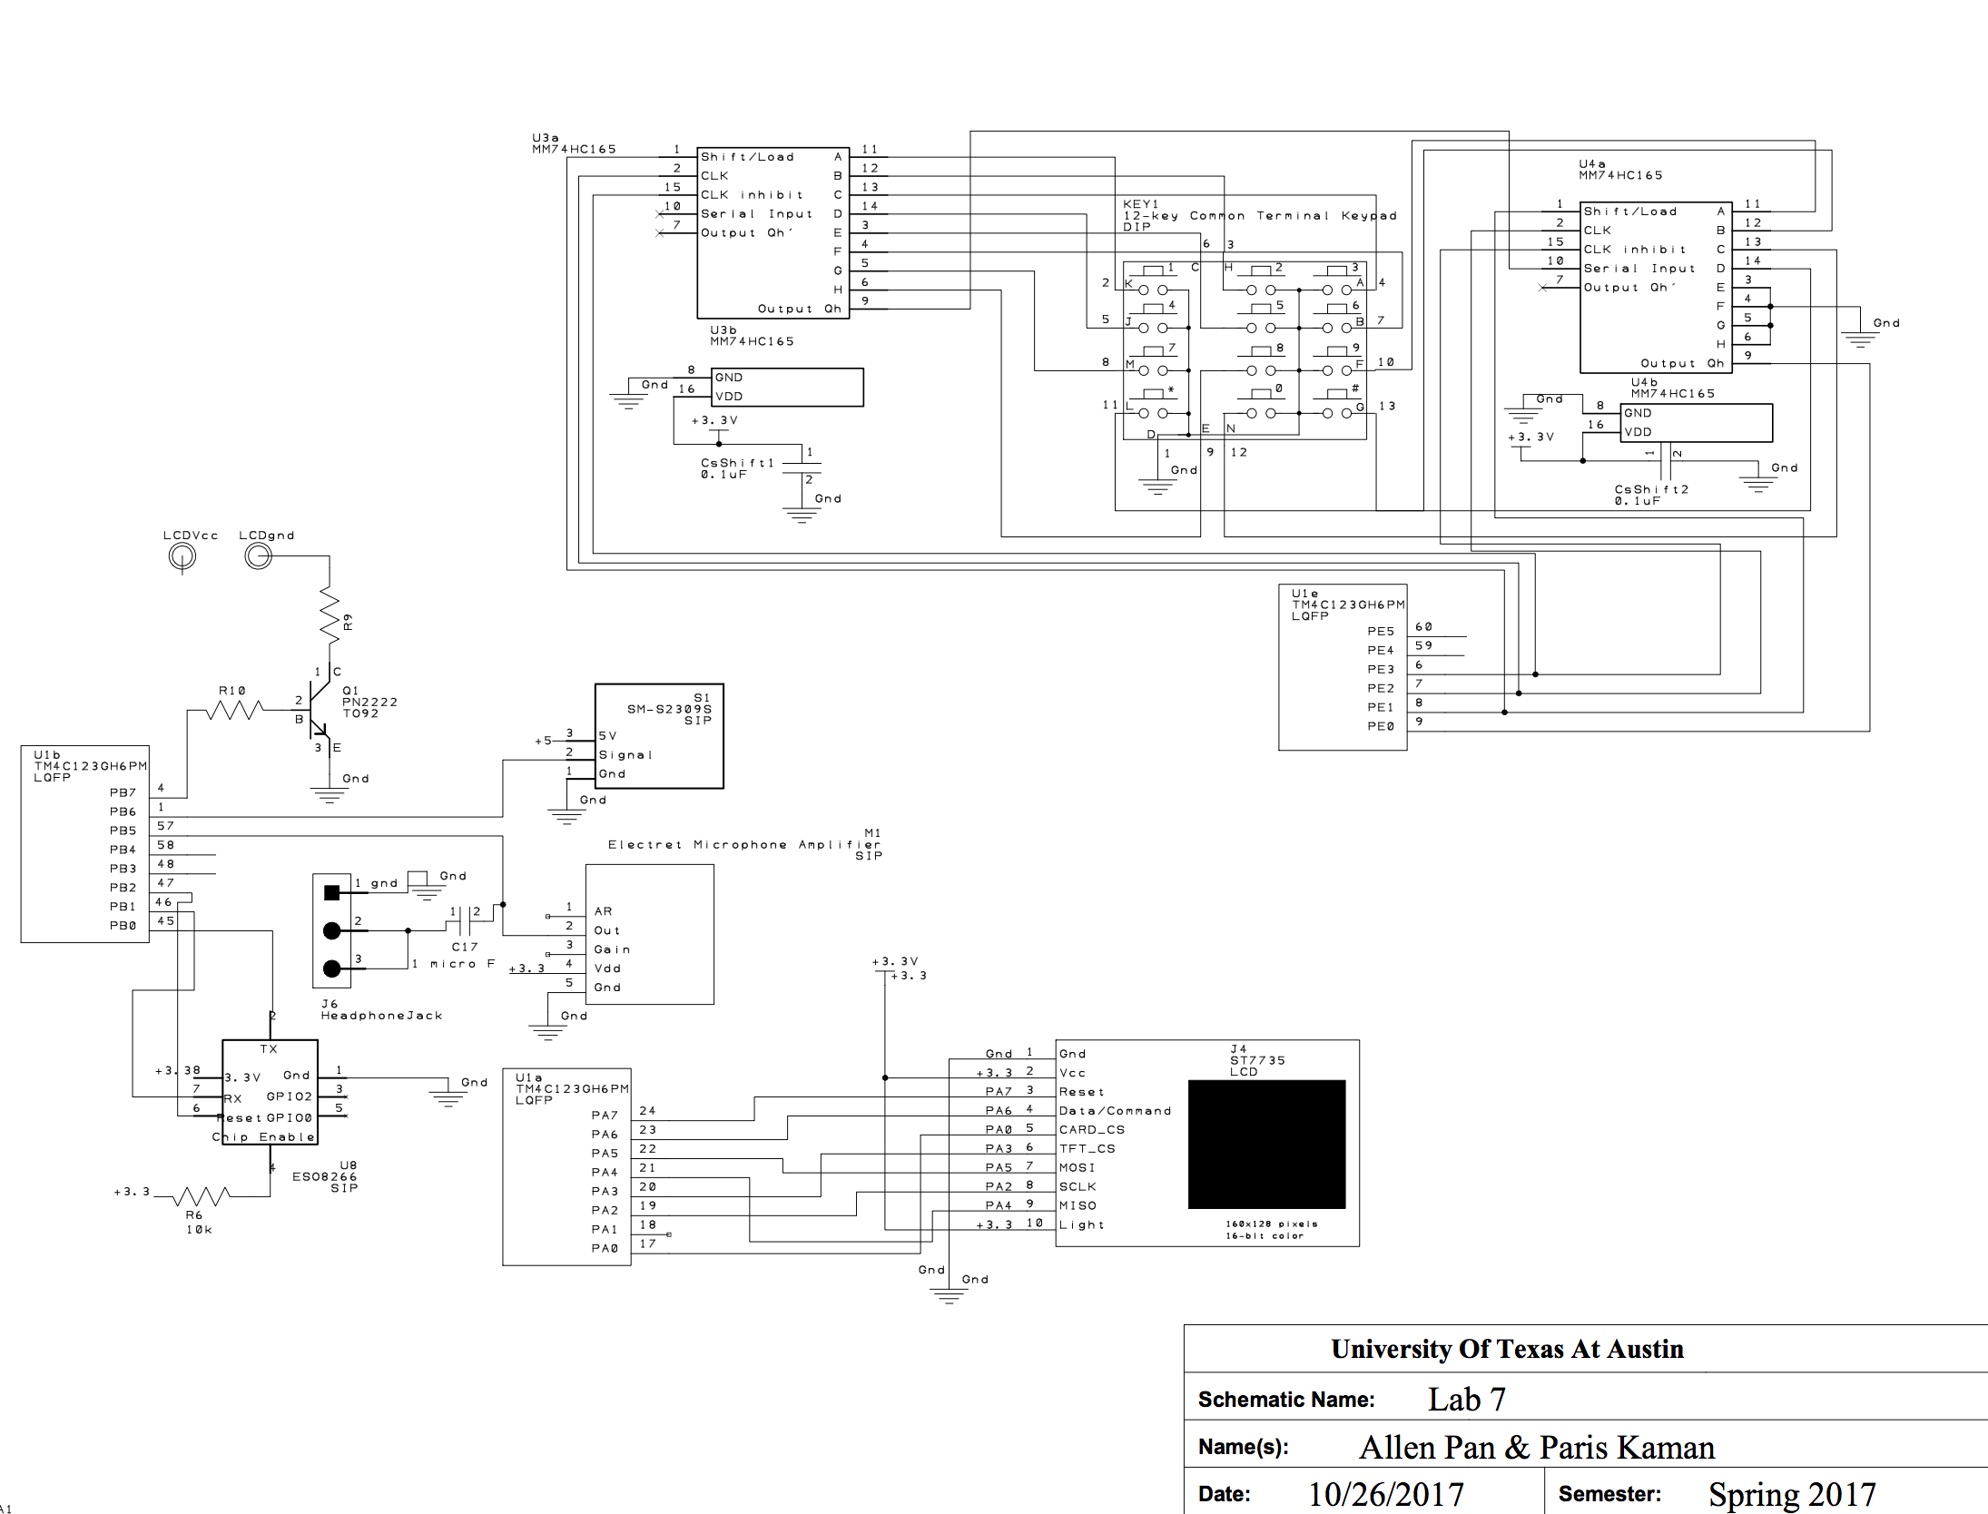

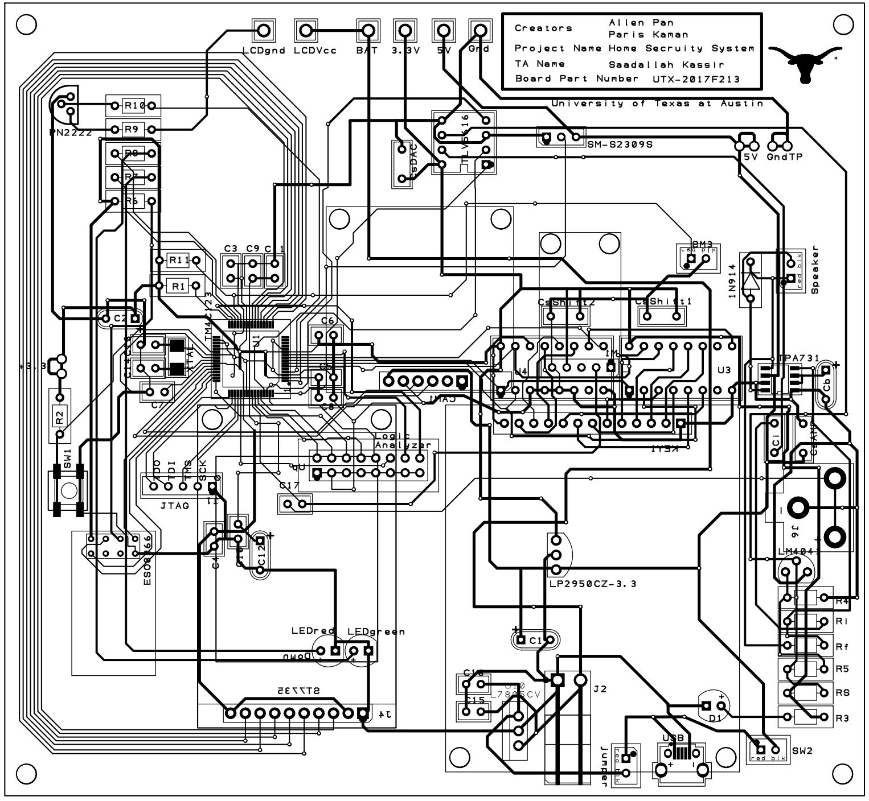

PCB

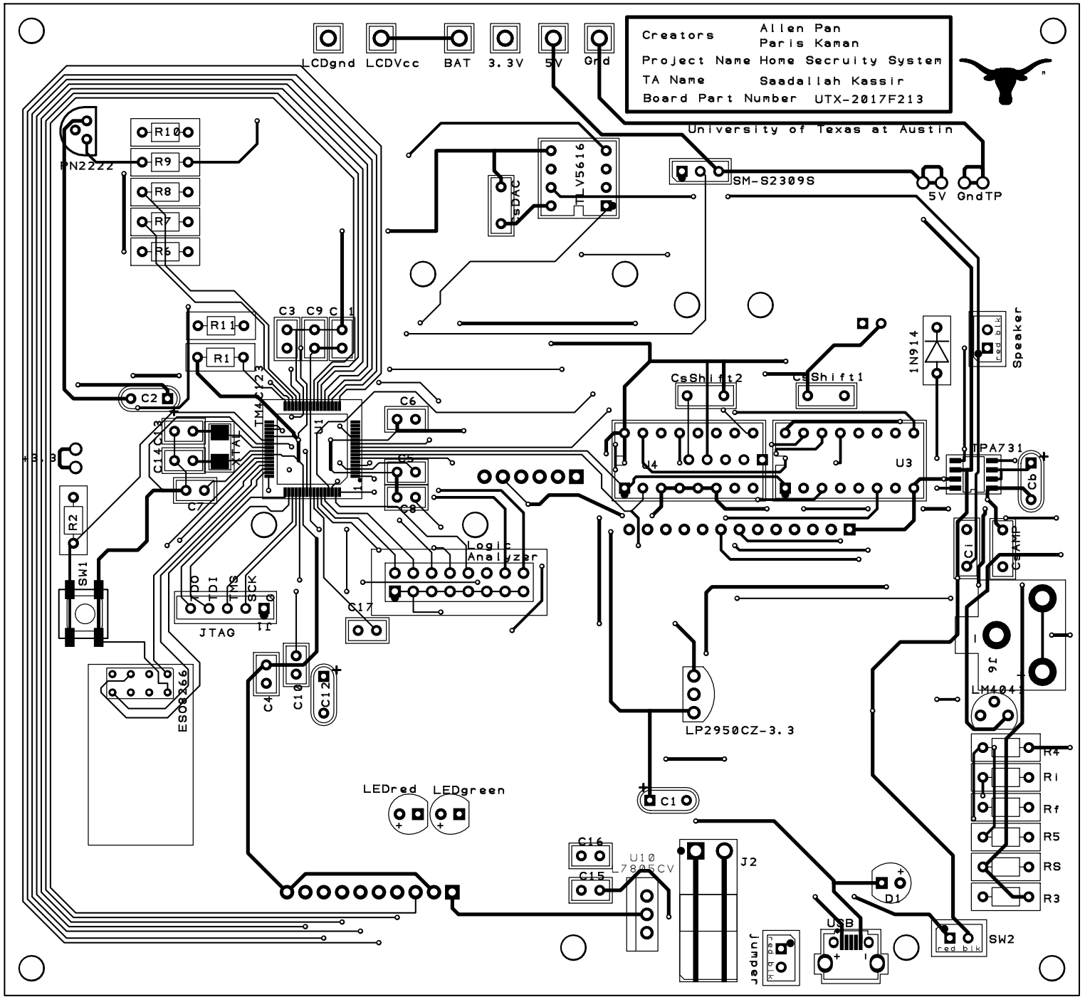

PCB Top Layer

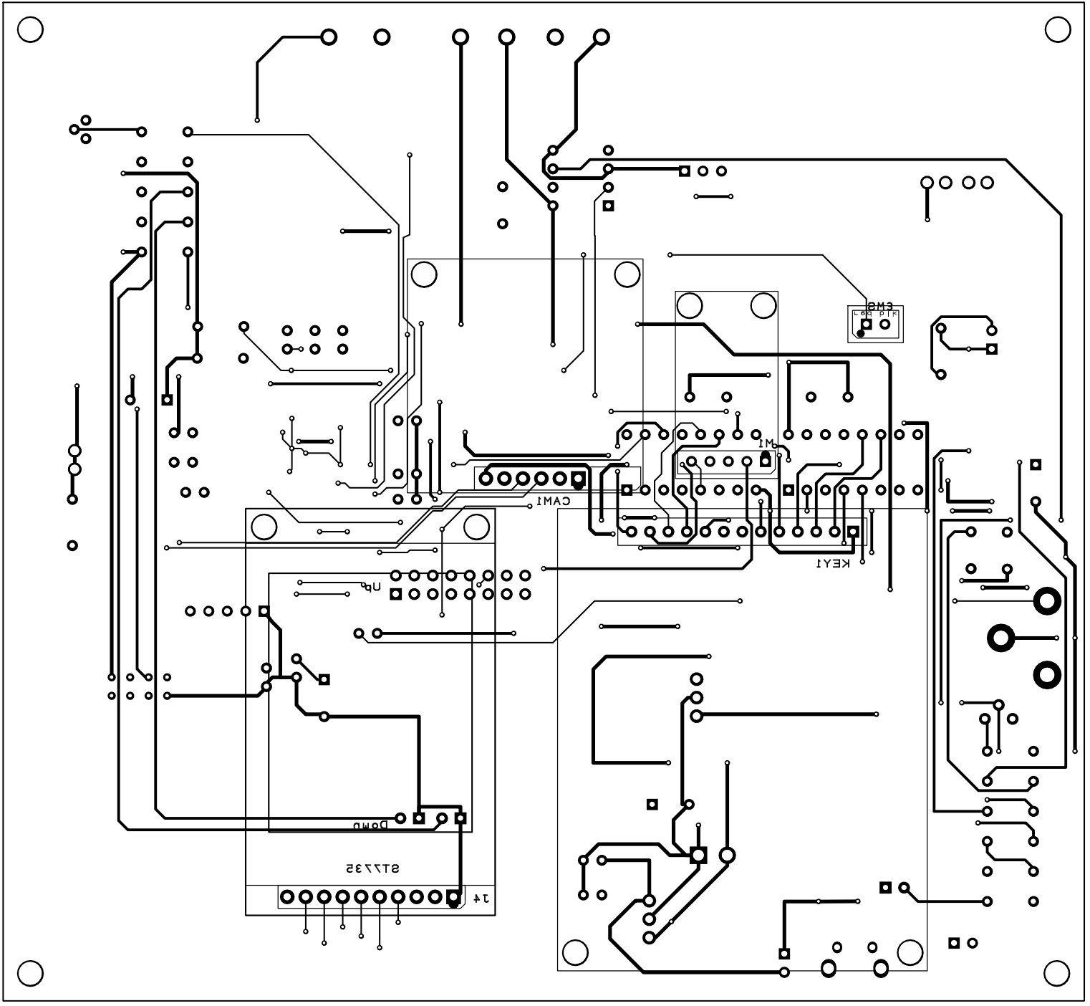

PCB Bottom Layer

D) Measurement Data

1. Give the estimated current (Procedure d)

Here are three voltage sources (or sort of): the 7.2 V battery (driving up to 2.5A), the output from 5V regulator L7805CV (driving up to 1A), and the output from 3.3V regulator LP2950 (driving up to 100mA). The estimated current draw for each major component:

LP2950: ESP8266: 80 mA

Microphone: 3.1 mA (amplifier) + 0.5 mA (microphone) ~ 4 mA

ST7735: 50 mA

L7805CV: Speaker (including amplifier): 100 mA

Camera: 75 mA

Battery: LCD: 350 mA

So the current output from LP2950 is likely to be not enough. We will replace it with a better regulator with the same package (so still works with our PCB).

2. Give the estimated cost (Procedure e)

$227.07

That’s the net worth counting everything we previously possessed, the parts we bought for this project specifically, the parts we get from Dr. McDermott, and the PCB ordering fee.

We are not going for the competition, so we just add up everything.

Here is the bill of materials.

E) Analysis and Discussion

 Include a copy of the reviewed SCH/PCB and signed by your professor

